IEEE Region 5 History Committee in cooperation

with Galveston Bay Section /Chapters presents

**AEROSPACE HISTORY COLLOQUIUM**

CELEBRATING THE 50th ANNIVERSARY OF IEEE AEROSPACE SOCIETY AND THE IEEE FOUNDATION

**VENUE: University of Houston Clear Lake DELTA Building**

**Saturday July 15th, 12:30-5:00 PM US-CDT**

**PROGRAM SPEAKERS**

**1-History of Aerospace:** Prof Dr. Jonathan Coopersmith, Professor of history Emeritus at Texas A&M, (<http://www.toboldlypreserve.space/>)  

**2-History of GPS/GRSS/GAGAN:** Dr Surendra Pal, Former Deputy Director, Indian Space Research Organization, and Former Vice Chancellor- Defence Institute of Advanced Technology, Poona-India

**3-History of RADAR**: Dr Hugh Griffiths, Prof University of London, England, Past President IEEE/AESS

**4-History of Systems Engineering and System of Systems (SoS)**: Dr Robert Rassa, Retired Raytheon, Past President IEEE/AESS, Distinguished Speaker

**5-Historical Pictures of the Space Activities**: Dr Kamlesh (Kam) Lulla; NASA Medalist. Director, University Collaboration and Partnership Office, NASA Johnson Space Center, Houston, Texas

**6-History of IEEE Foundation** : Dr John Treichler, Raytheon, IEEE Foundation

**7- CLOSING PANEL DISCUSSION/ MODERATION**: Dr. Mary Ann Hellrigel, IEEE/History Committee Institutional Historian **ONLINE MODERATION**

**HOSTED by the University of Houston Clear Lake.**

**Colloquium Coordinator: Dr Zafar Taqvi/IEEE Region 5 History Chair**

Colloquium is hybrid, Registration is **COMPLIMENTARY**. Both in-person and online attendees need to register with Vtools at URL **https://** **https://events.vtools.ieee.org/event/register/363026.**

**Colloquium Speakers**

Aerospace History :

Dr Jonathan Coopersmith

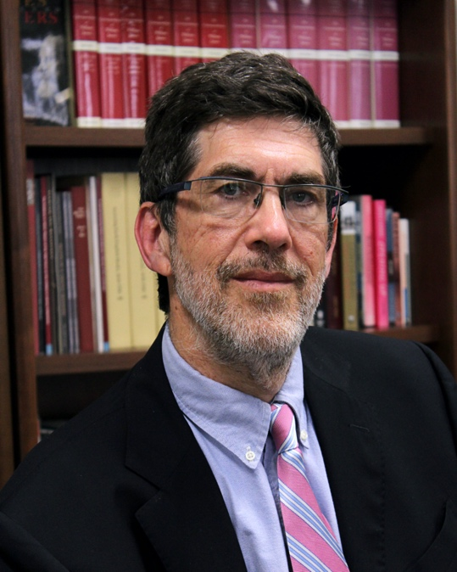

Jonathan Coopersmith ([j-coopersmith@tamu.edu](mailto:j-coopersmith@tamu.edu)) is a Professor Emeritus of History at Texas A&M University, where he taught the history of technology and wrote about Russian electrification, space commercialization and the 180-year history of the fax machine. His current research includes failure in technology, the importance of frothy and fraudulent firms in emerging technologies, and ensuring the preservation of space-related archives. He co-organized the 2018 NSF-funded To Boldly Preserve: Archiving the Next Half-Century of Spaceflight conference ([www.toboldlypreserve.space](http://www.toboldlypreserve.space)). An IEEE Senior Member, he has served on the IEEE History Committee.

GPS/GRSS/GAGAN History:

Dr Surendra Pal

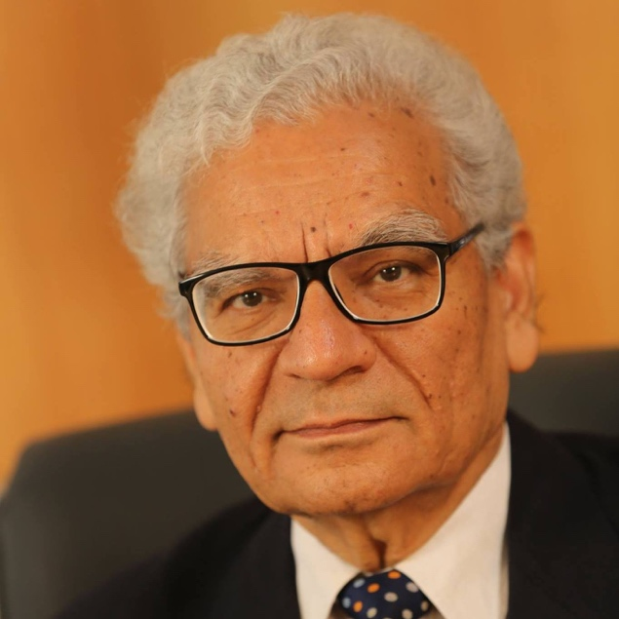

Dr. Surendra Pal, a researcher and an academician of international repute having more than 52 years of experience in the field of Antennas, Microwaves, Space Communication and Satellite Navigation, is the Former: Vice-Chancellor of Defence Institute of Advanced Technology (DIAT), Pune, *DRDO Dr.DS Kothari Chair, Distinguished Scientist, Prof. Satish Dhawan Professor, Senior Adviser, Satellite Navigation (lSRO), Distinguished Scientist and Associate Director of ISRO Satellite Centre (Presently URSC) Bangalore.*

*Dr. Pal was the founder Programme Director of Indian Satellite Navigation Programme GAGAN and NavIC. He conceptualised and then worked for the projects. The NavIC (IRNSS) constellation is a unique constellation at GEO orbit for Regional Navigation, providing better position and timing, stand-alone, accuracies, for navigation. US GPS is now following this concept for its new GPS series.*

He was responsible for initiating: Antennas, Space communication, Microwaves and Satellite navigation activities at ISRO Satellite Centre (ISAC) from its inception.

*Dr. Pal was an IEEE(US) Distinguished Lecturer for the Aerospace Electronics Society. Dr. Pal is a Member, Fellow and Distinguished Fellow of several national and International Professional Societies including Life - IEEE, IET(UK),MIAA(Paris), Chartered Engineer (UK), Distinguished Fellow ASI and IETE, FNASc, FNAE, FVEDA &FAMTS.*

History of IEEE Foundation:

Dr John Treichler

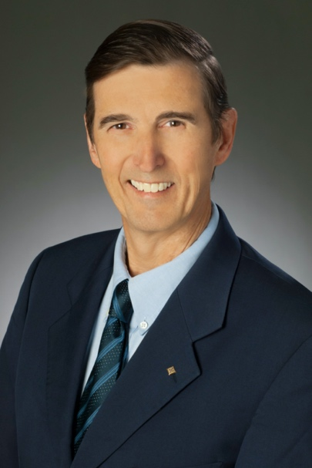



History of Radar:

Dr Hugh Griffiths

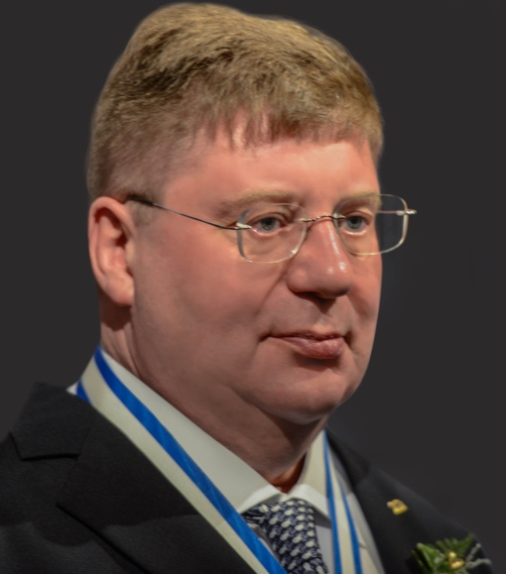

Hugh Griffiths holds the THALES/Royal Academy Chair of RF Sensors in the Department of Electronic and Electrical Engineering at University College London, England, and is Chair of the Defence Science Expert Committee (DSEC) in the UK Ministry of Defence.  From 2006–2008 he served as Principal of the Defence Academy College of Management and Technology. He received the MA degree in Physics from Oxford University in 1975, then spent three years working in industry, before joining University College London, where he received the PhD degree in 1986 and the DSc(Eng) degree in 2000, and served as Head of Department from 2001–2006.  
  
His research interests include radar systems and signal processing (particularly bistatic radar and synthetic aperture radar), and antenna measurement techniques.  He serves as Editor-in-Chief of the IET Radar, Sonar and Navigation journal. He has published over five hundred papers and technical articles in the fields of radar, antennas and sonar.  He has received several awards and prizes, including the IEEE Picard Medal (2017), IET Achievement Medal (2017), the IEEE AES Mimno Award (2015 and 2021), the IET A.F. Harvey Prize (2012) and the IEEE AES Nathanson Award (1996). He is a Fellow of the IET and a Fellow of the IEEE. In 2019 he was appointed OBE in the New Year’s Honours List, and in 2021 he was elected Fellow of the Royal Society.

History of Systems Engineering and System of Systems (SoS):

Dr Robert Rassa

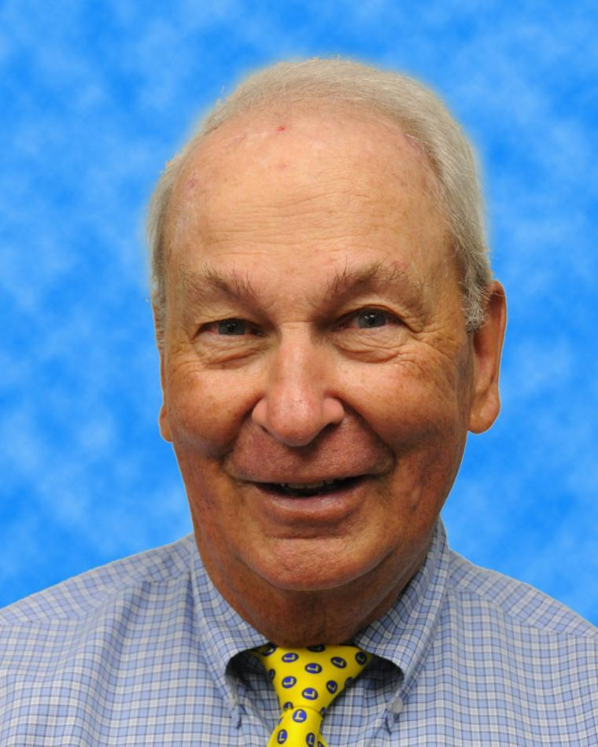

Bob Rassa is the retired Director of Engineering Programs at Raytheon Technologies Intelligence and Space Systems, El Segundo CA and Fallston MD, since April 1996. Responsibilities were primarily helping improve systems engineering capabilities throughout Raytheon, and assisting the US Department of Defense and the Services (USAF, USA, USN, USMC) and Agencies improve their systems engineering capabilities via Industry Association and IEEE activity focused on systems engineering. Experienced in program management, systems engineering, radar systems design, logistics, test systems, and other electronics design. Mr. Rassa is founder and Chairman Emeritus of the National Defense Industry Association (NDIA) Systems Engineering Division, as well as a founding member of their Automatic Test Committee. Mr. Rassa holds a BSEE from the University of California – Berkeley. He holds the US Patent for a satellite-based Advanced Maintenance System for Aircraft & Military Weapons, issued in August 1999, now being used on the F-22 and F-35. This patent is also the basis for General Motors’ Digital “On-Star” System. He is recipient of the IEEE Third Millennium Medal, the McGinnis Professional Achievement Award from IEEE-AUTOTESTCON, the IEEE Distinguished Service Award from the IEEE Instrumentation & Measurement Society, IEEE Distinguished Service Award from the IEEE Systems Council, and was elected to the IEEE Technical Activities Board Hall of Honor (Nov 2016).

Historical Aerospace Photographs through the Era:

Dr Kamlesh Lulla

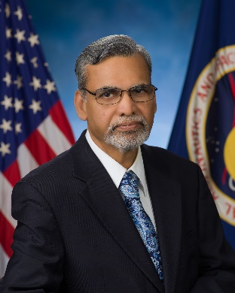

Dr. KAMLESH LULLA is an award-winning, internationally acclaimed NASA senior scientist and an expert in space and geospatial technology who is senior leader at NASA.

Dr Lulla’s distinguished career at NASA spans 35 years where he has served as the Chief Scientist for Earth Observation for Space Shuttle and International Space Station programs, directed the training of NASA Astronauts in Earth Observation Sciences and physical science payloads. Dr Lulla’s scientific research involved optical and radar remote sensing and advanced sensor development. In addition, Dr Lulla developed digital imaging sensors as payloads for the space shuttle program. In his leadership roles at NASA, Dr Lulla also served as Chief for Flight Science branch for five years and Chief for Earth Science branch for five years. He also serves as the Chief Scientist for ten years.

Dr. Lulla has received numerous awards from NASA, the U.S. Government and various universities, cultural organizations, and associations. Dr. Lulla has received several awards from professional societies such as the American Institute of Aeronautics and Astronautics (AIAA), American Society of Photogrammetric Engineering and Remote Sensing (ASPRS) and Association of American Geographers. Dr Lulla received three of the highest NASA medals- the NASA Exceptional Achievement Medal in 2005 for his scientific research and NASA sponsored Astronaut Ellison Onizuka Award (medal) for his scientific and technical excellence in 2012 and NASA Achievement Medal for technology in 2015.

Panel Moderator:

Mary Ann Hellrigel

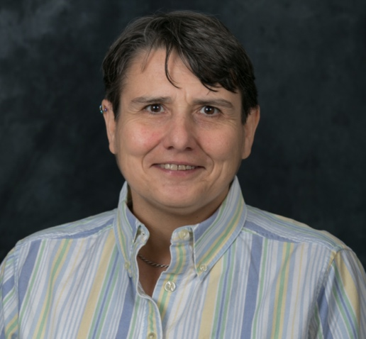

Since January 2016, Mary Ann C. Hellrigel, Ph.D., has been the Institutional Historian, Archivist, and Oral History Program Manager at the IEEE History Center.  She also manages the History Center’s oral history program.  She is the recipient of the IEEE Fellowship in Electrical History, 1993-1994 [now the IEEE Life Member History Fellowship].

Mary Ann has a bachelor's degree in History and Biology from Rutgers University (1983); a master's degree in Public History from UC-Santa Barbara (1989); and a Ph.D. in History of Technology and Science from Case Western Reserve University. She served as a Research Associate and editor at the Thomas A. Edison Papers Project, and for more than 30 years, she taught history, women’s history, American Studies, and geography at universities in the USA, including at Stevens Institute of Technology; California State University, Chico; New Jersey Institute of Technology; Iowa State University; and The State University of New York, College at Geneseo.

Mary Ann has widely published and presented papers on Edison and early electric power and has consulted on related exhibits and documentaries. She has been active in the Society for the History of Technology, having served on several prize committees.

Colloquium Coordinator:

Dr Zafar Taqvi

IEEE R5 History Chair

Past Chair IEEE Galveston Bay Section, Chair AESS Joint Chapter

Fellow ISA, Associate Fellow AIAA, LSM-IEEE

Research Fellow University of Houston Clear Lake